**Task No.01**

**1) Identify the main function of the network layer**

Provides services to allow end devices to exchange data,

It also provides 4 basic operations: Addressing end devices, Encapsulation, Routing, De-encapsulation.

**2) Describe the characteristics of IP protocol**

* IP is Connectionless:
  + IP does not establish a connection with the destination before sending the packet.
  + There is no control information needed (synchronizations, acknowledgments, etc.).
  + The destination will receive the packet when it arrives, but no pre-notifications are sent by IP.
  + If there is a need for connection-oriented traffic, then another protocol will handle this (typically TCP at the transport layer).
* IP is Best Effort:
  + IP will not guarantee delivery of the packet.
  + IP has reduced overhead since there is no mechanism to resend data that is not received.
  + IP does not expect acknowledgments.
  + IP does not know if the other device is operational or if it received the packet.
* Media Independent
  + IP is unreliable:
    - It cannot manage or fix undelivered or corrupt packets.
    - IP cannot retransmit after an error.
    - IP cannot realign out of sequence packets.
    - IP must rely on other protocols for these functions.
* IP is media Independent:
  + IP does not concern itself with the type of frame required at the data link layer or the media type at the physical layer
  + IP can be sent over any media type: copper, fiber, or wireless

**3) Message segmentation into packets increase the efficiency, explain.**

Segmentation of messages into packets allows for more efficient data transmission across networks. It enables better bandwidth utilization, error handling (retransmission of lost packets), and flexibility in routing smaller units of data through diverse network paths

Only segments which fail to reach the destination need to be retransmitted, not the entire data stream

**4) Efficiently design "Build" Your own Network**

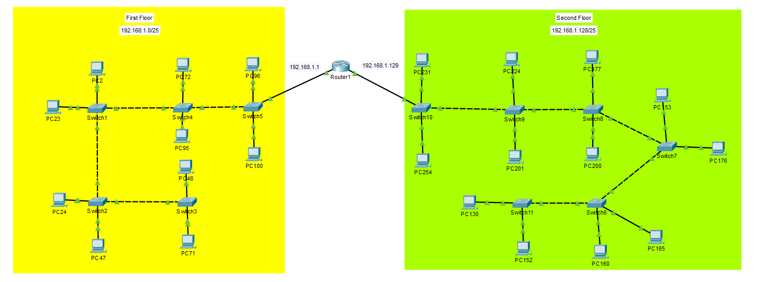

**2) How many routers and switches you use in your design**

1 Router, 11 Switches

**3) Show the number of Subnets.**

2 Subnets

**4) Show the number of Subnets.**

IP: 192.168.1.0/24

Subnet: 255.255.255.0 🡪 1111 1111.1111 1111.1111 1111.0000 0000

No. of hosts = 120

2n  = 122 🡪 n = ⌈ log2(122) ⌉ 🡪 **n = 7**

**Hop =** 128

**New subnet (binary) =** 1111 1111.1111 1111.1111 1111.1000 0000

**New subnet (decimal) =** 255.255.255.128

**First floor**

Subnet Musk: 255.255.255.128

Network address: 192.168.1.0/25

No. of IPs can be used: 27 – 2 (broadcast, network IP): 126

No. of Available Hosts: 126 (100 used – 26 Available)

Broadcast Address: 192.168.1.127

First Host Address: 192.168.1.1

Last Host Address: 192.168.1.126

**Second floor**

Subnet Musk: 255.255.255.128

Network address: 192.168.1.128/25

No. of IPs can be used: 27 – 2 (broadcast, network IP): 126

No. of Available Hosts: 126 (120 used – 6 Available)

Broadcast Address: 192.168.1.255

First Host Address: 192.168.1.129

Last Host Address: 192.168.1.254

**Task No.2**

**1) Define the function of data link layer.**

* The Data Link layer is responsible for communications between end device network interface cards.
* It allows upper layer protocols to access the physical layer media and encapsulates Layer 3 packets (IPv4 and IPv6) into Layer 2 Frames.
* It also performs error detection and rejects corrupts frames.

**2) Explain the meaning of Contention-based access**

All nodes operating in half-duplex, competing for use of the medium. Examples are:

* Carrier sense multiple access with collision detection (CSMA/CD) as used on legacy bus-topology Ethernet.
* Carrier sense multiple access with collision avoidance (CSMA/CA) as used on Wireless LANs

**3) Differentiate between CSMA/CD and CSMA/CA**

|  |  |
| --- | --- |
| **CSMA/CD** | **CSMA/CA** |
| Used by legacy Ethernet LANs | Used by IEEE 802.11 WLANs |
| Operates in half-duplex mode where only one device sends or receives at a time | Operates in half-duplex mode where only one device sends or receives at a time |
| Uses a collision detection process to govern when a device can send and what happens if multiple devices send at the same time | Uses a collision avoidance process to govern when a device can send and what happens if multiple devices send at the same time |
| Devices transmitting simultaneously will result in a signal collision on the shared media. | When transmitting, devices also include the time duration needed for the transmission |
| Devices detect the collision | Other devices on the shared medium receive the time duration information and know  how long the medium will be unavailable |
| Devices wait a random period of time and retransmit data |  |

**4) Differentiate between different frame forwarding methods on Cisco**

**Switches**

There are 2 methods that all switch use for forwarding the frames (switching data) between the network ports:

1. Store-and-forward switching

This frame forwarding method receives the entire frame and computes the CRC. If the CRC is valid, the switch looks up the destination address, which determines the outgoing interface. Then the frame is forwarded out of the correct port.

1. Cut-through switching

This frame forwarding method forwards the frame before it is entirely received. At a minimum, the destination address of the frame must be read before the frame can be forwarded.

**5) List the three types of routes in a router’s routing table.**

1. Directly Connected

These routes are automatically added by the router, provided the interface is active and has addressing.

1. Remote

These are the routes the router does not have a direct connection and may be learned:

* + Manually – with a static route
  + Dynamically – by using a routing protocol to have the routers share their information with each other.

1. Default Route

This forwards all traffic to a specific direction when there is not a match in the routing table.

**6) Change the host name of each router to "R n**



**7) Change the host name of each switch to "S n"**



**8) Make an encrypted password for the privilege mode for each router and switch in this Network.**





**9) Show all configurations of routers and switches of this Network.**

Router Configuration

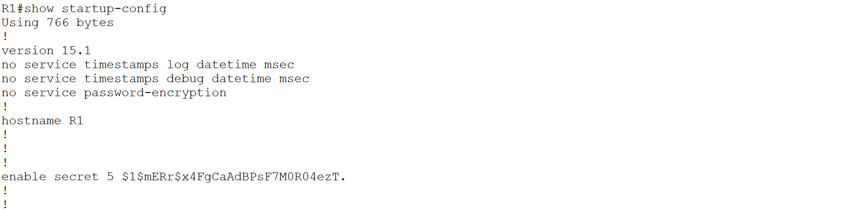

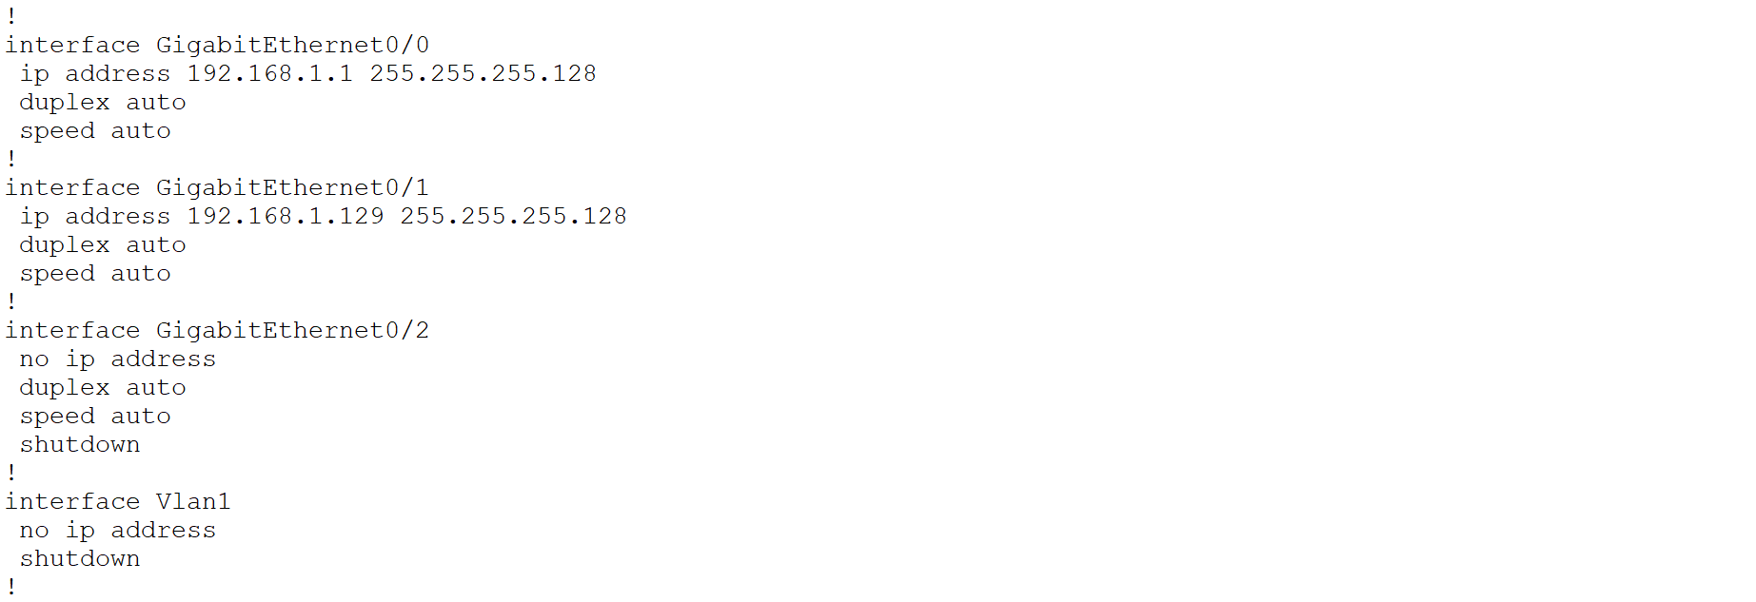

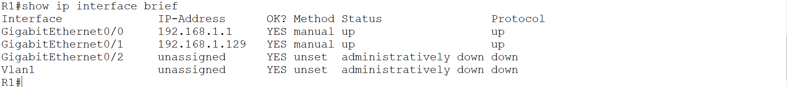

Switch Configuration

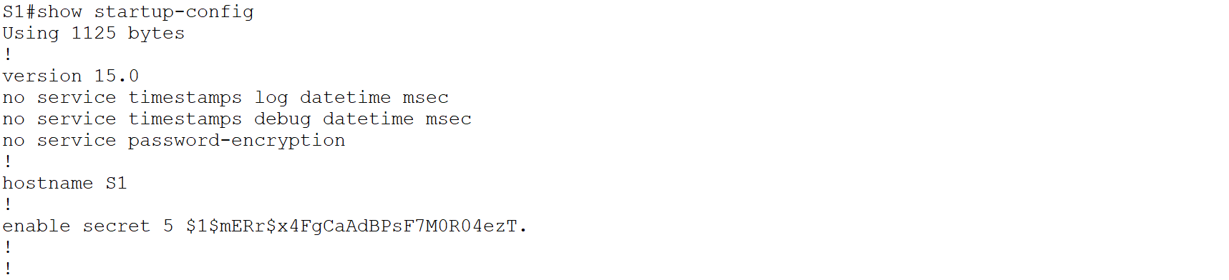

**10) Use ICMP protocol to check the connectivity between the end devices in this Network.**

